2.1) JOBS – DETAILS – INPUT SCREEN
Selection key
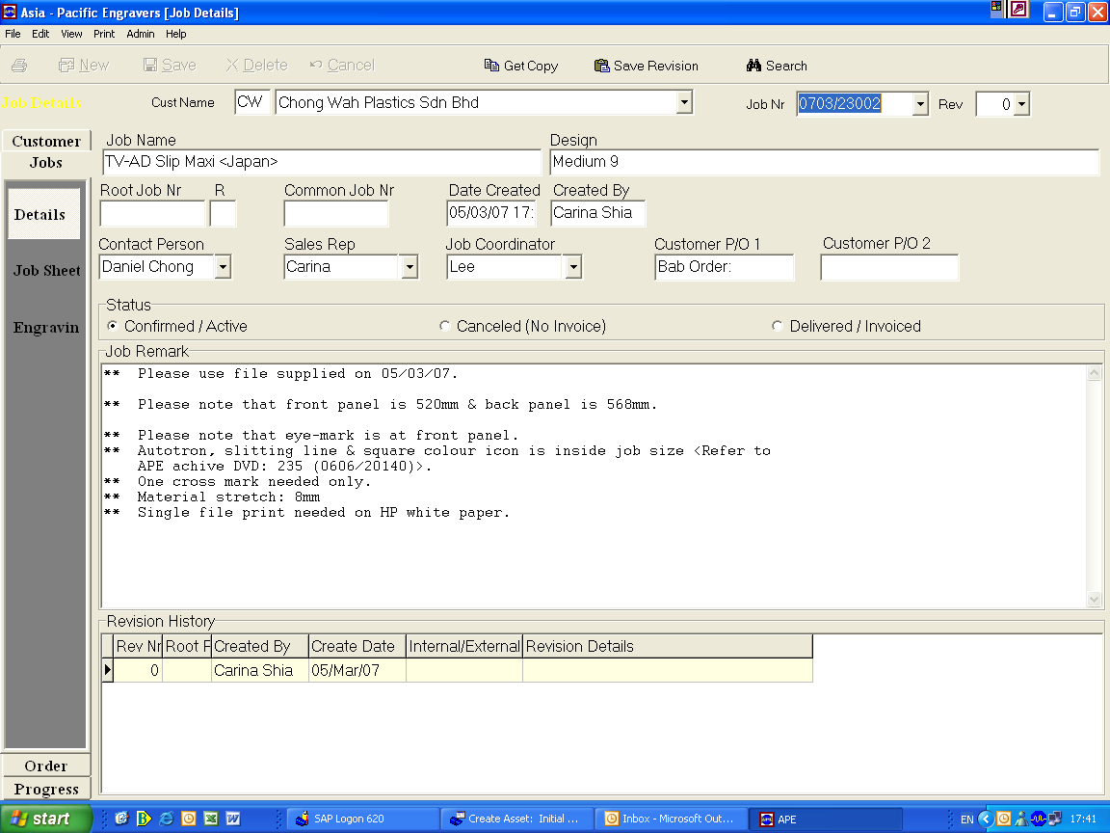
Retrieve from OC screen
OVERVIEW
To create a new job in the system, key in general information for new job.
To view the status, remarks & revision history of job.

RESPONSIBILITY
Sales personnel, Repro & logistic

PROCESS PROCEDURE
On screen “Jobs – Details” , there are 2 type of job.
- New engraving - select the customer using selection key, enter the information as specific below, click “save” button & job number will automatic created.
Note : all field circle will auto generated by system

INPUT REQUIRED FIELD

Field Name | Description | Comments
Job Name | Name of job | As per customer job sheet
Design | Design of job | As per customer job sheet
Contract Person | Use selection key | Selection taken fr. Customer details
Sales Representative | Use selection key | Selection taken fr. Customer details
Job Remark | Additional information for job | As many info. As possible.

If the job need to do an revision, click on “Save Revision” button. Pop up window will come out to confirm the revision. After click “Yes” , immediately in the revision history will show.
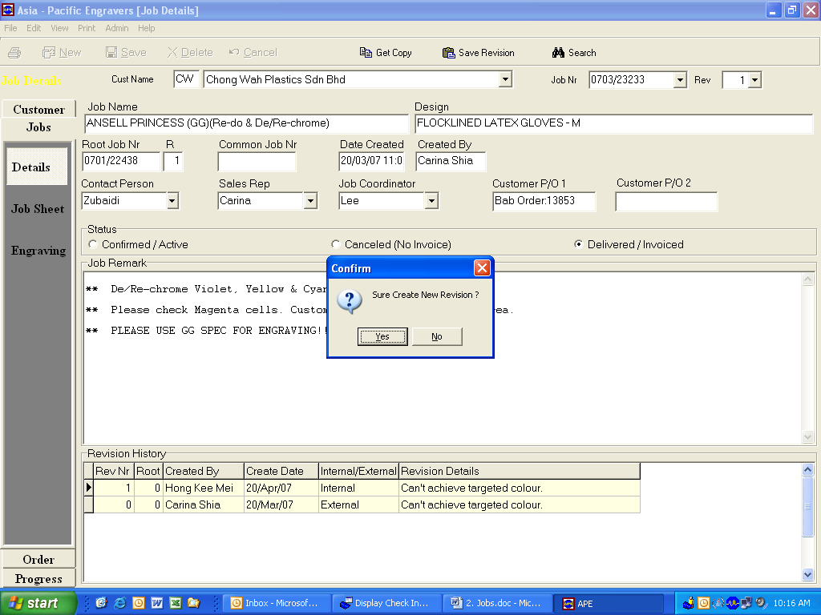

Further screen will come out for revision reason. We can put in the details for revision the close the screen.
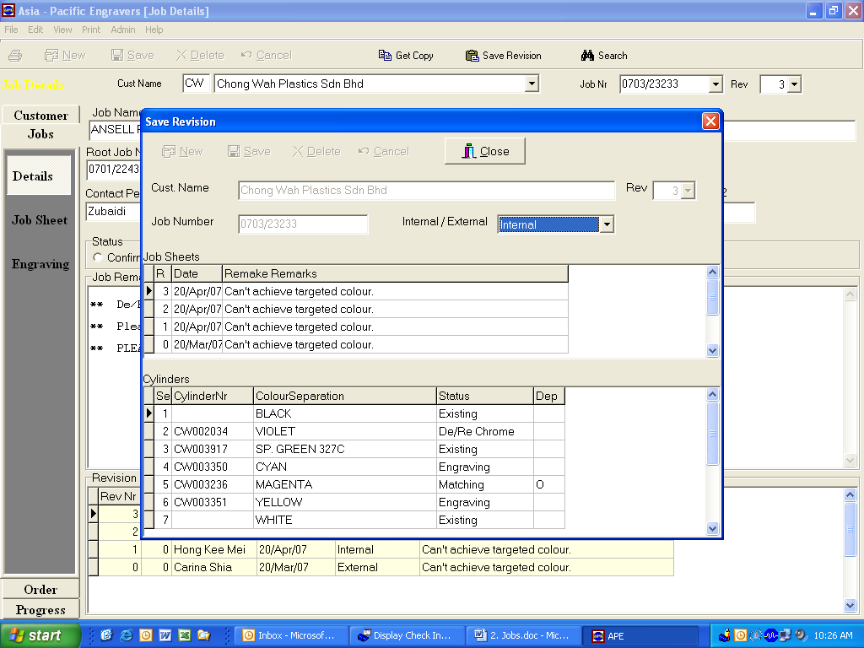

- Re-engrave – to re-engrave cylinder which had engraved before. We can copy the existing job details to the new re-engrave order. Select the customer using selection key, click the “Search” button.

A pop up window will come out, key in customer name & keyword we want to search then click “search”. All jobs with same keyword will appear, double click the job you would like to copy.

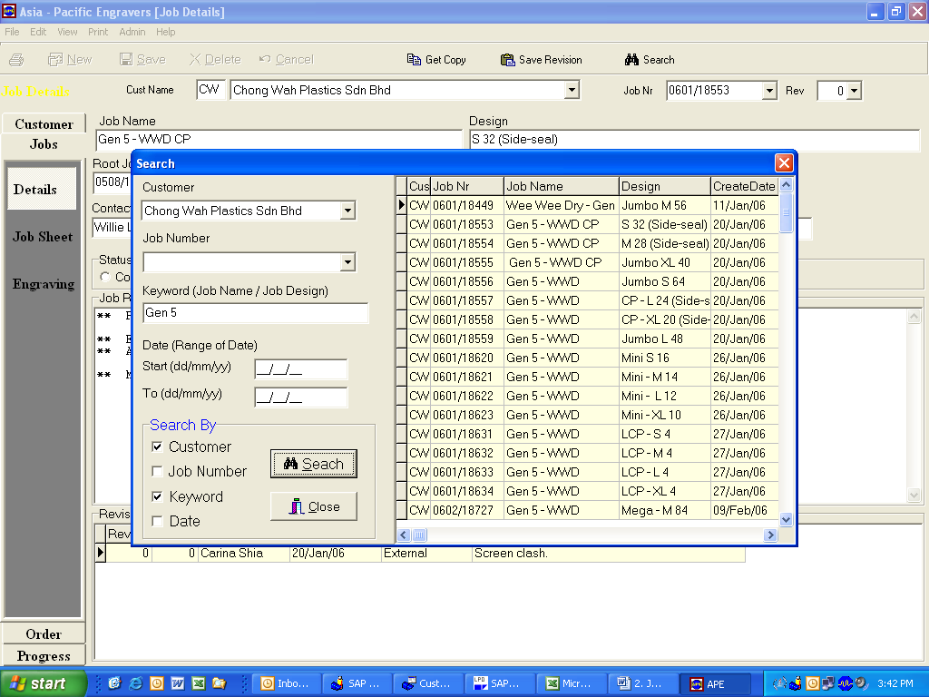

Example – this job had been selected to copy, click “Get Copy” button.
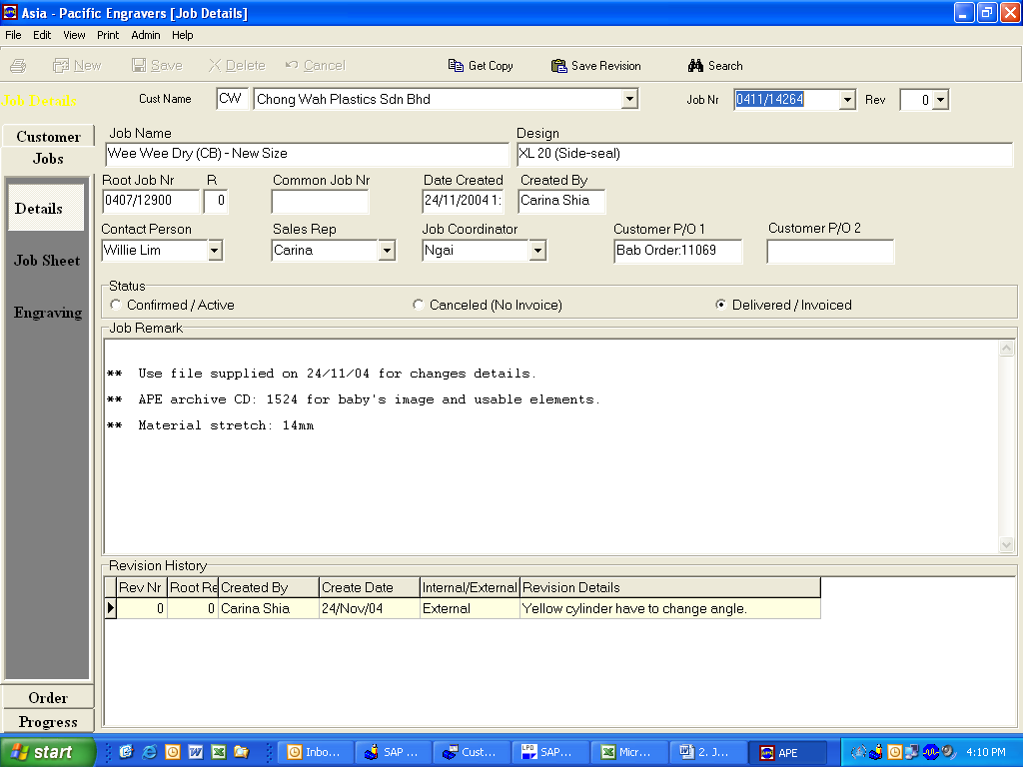

A pop up window will come out showing the details of job we are going to copy. Then click “Get Copy” button.
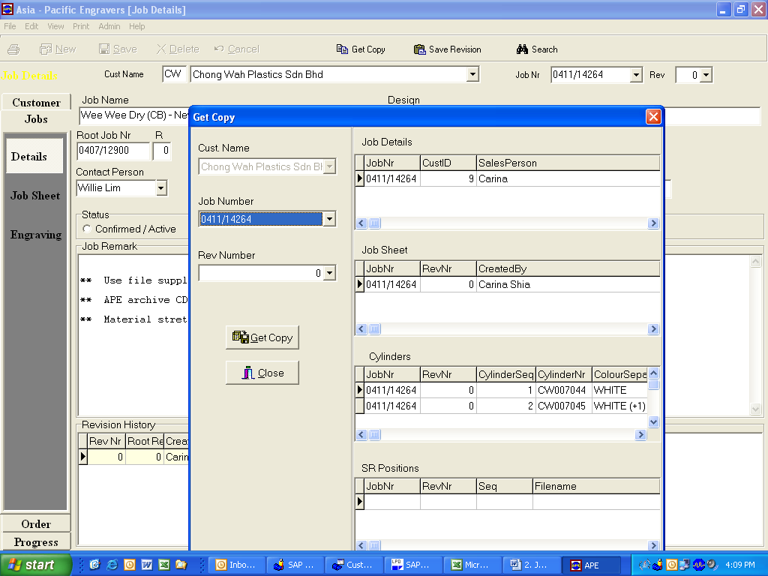
A new job number will be created and the existing job number used to copy will show as root job number.
New job number
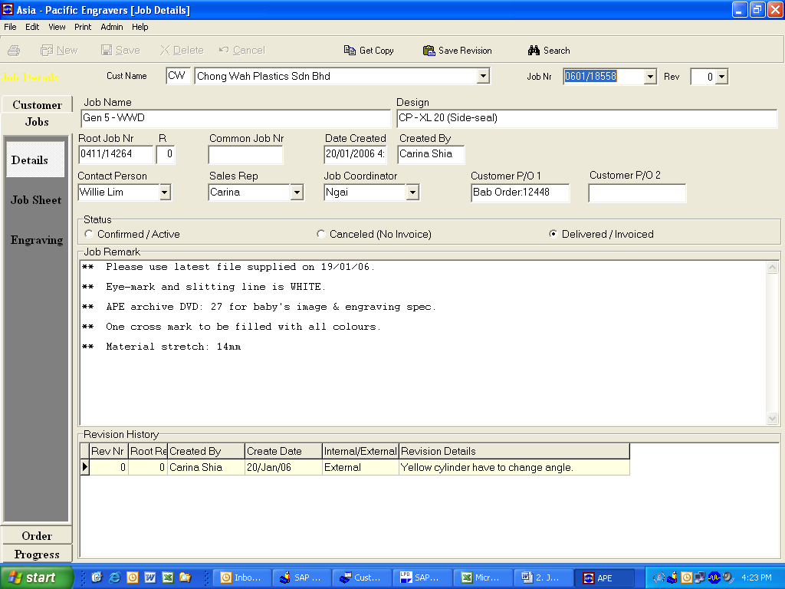

Sales personnel will change some information to according to new requirements and this function will save the time of key in general information.

2.2a) JOBS – JOB SHEET – PARAMETER – INPUT SCREEN

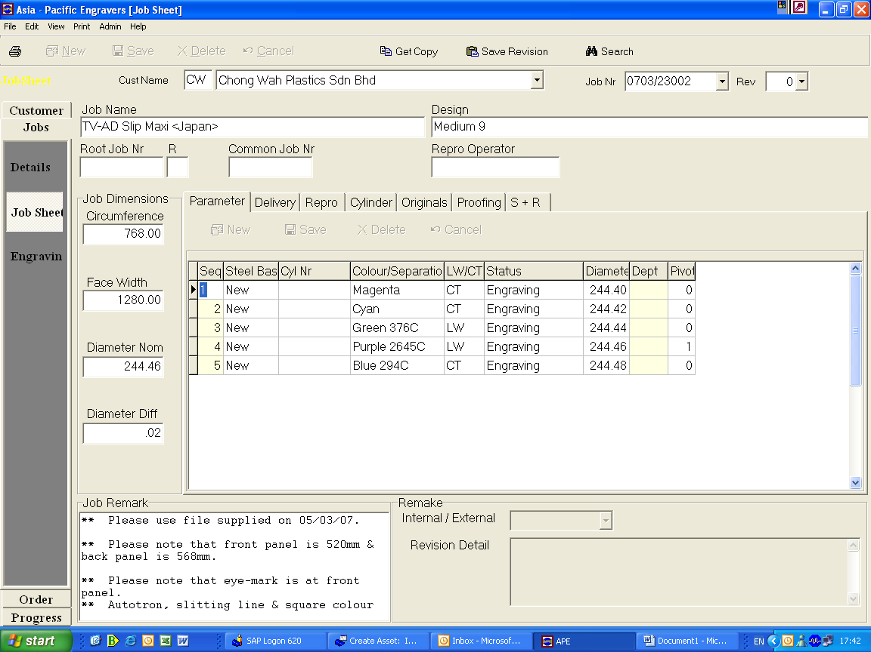
Formula field
OVERVIEW
Input parameter of the job.

RESPOSIBILITY
Sales Personnel

PROCESS PROCEDURE
On screen “JOBS – JOBSHEET - PARAMETER”, enter information required as below.

Field Name | Description | Comments
Circumference | Cylinder circumference
Face width | Cylinder face width
Parameter – Seq.  Parameter – Steel Base  Parameter- Cyl. Nr  Parameter – Colour  Parameter- LW/CT  Parameter – Status  Parameter – Pivot | No. of cyl. To be engrave  Cylinder base new or old  Auto running no. by. Sys. (double click the field)  Colour for the printing  Selection  For engraving or De-Re chrome – Selection  Printing process tolerance | New – order, Old – customer cyl.  New cylinder will have new number but for re-engrave cylinder will use back the same number, if cylinder from customer the field will blank.  Usually cyl. In middle to put 1

2.2b) JOBS – JOB SHEET – DELIVERY – INPUT SCREEN

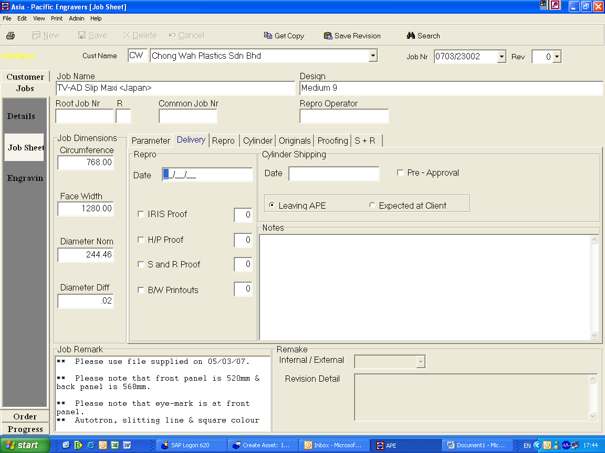

OVERVIEW
Input delivery information of the job.

RESPOSIBILITY
Sales Personnel

PROCESS PROCEDURE
On screen “JOBS – JOB SHEET – DELIVERY”, enter the date of proof print to customer for approval, types of proof print & no. of copies customer required.

2.2c) JOBS – JOB SHEET – REPRO – INPUT SCREEN

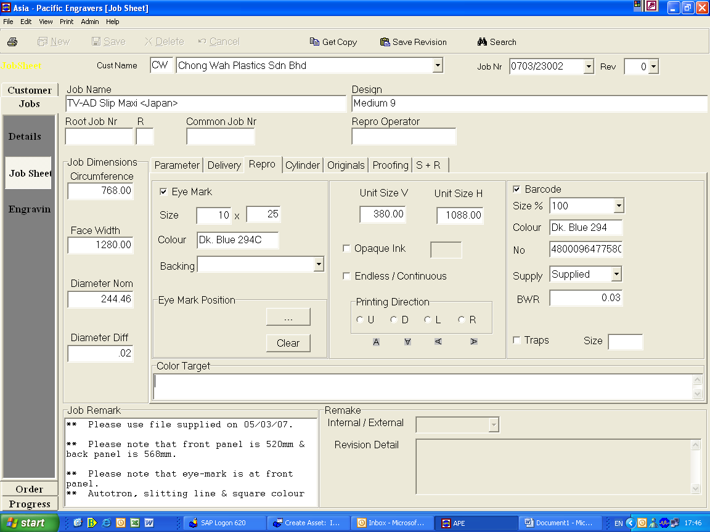

OVERVIEW
Input information to repro dept. on the customer requirement.

RESPOSIBILITY
Sales Personnel

PROCESS PROCEDURE
On screen “JOBS – JOB SHEET – REPRO”, enter the information in the highlighted square field. For job with eye mark position click on “---“ button.

A pop up window will appear, select the eye mart position and close. The eye mark position will show in the field.

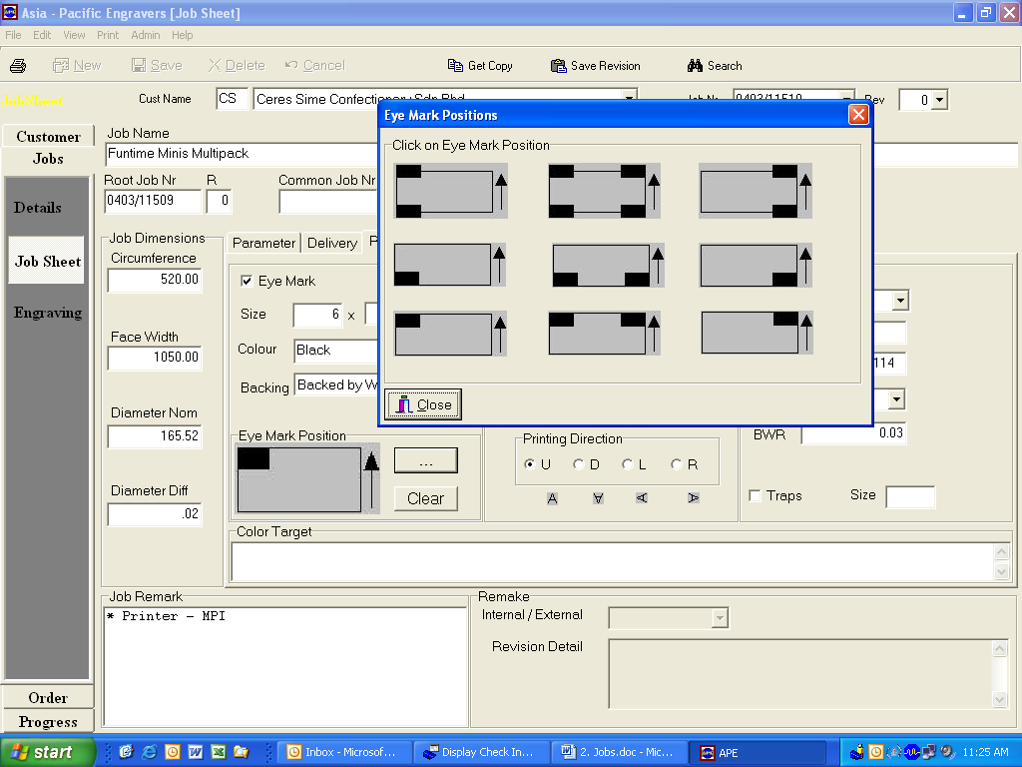

2.2d) JOBS – JOBSHEET – CYLINDER – INPUT SCREEN

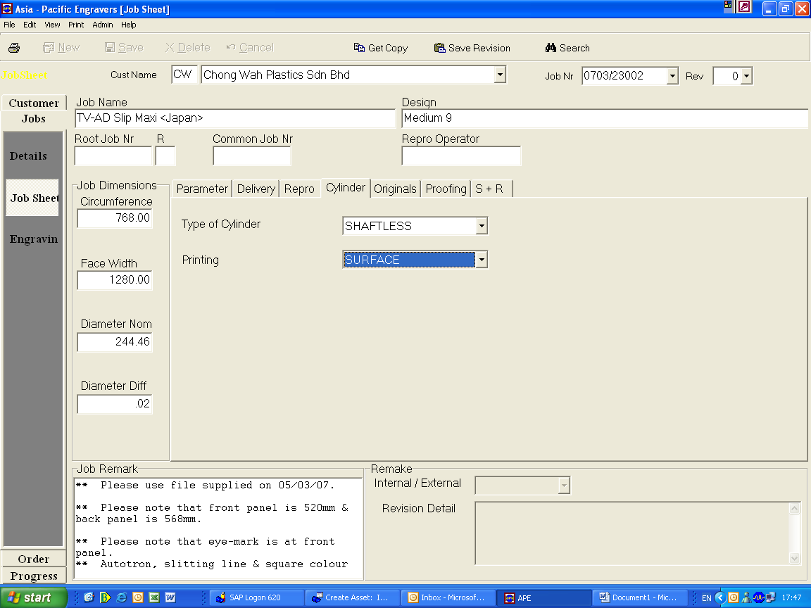

OVERVIEW
Input information on cylinder to use.

RESPOSIBILITY
Sales Personnel

PROCESS PROCEDURE
On screen “JOBS – JOB SHEET – CYLINDER”, select type of cylinder and printing.

TYPE OF CYLINDER 1) SHAFT - FOR TOBACCO
2) SHAFTLESS - FOR HOLLOW CYLINDER (FLEXIBLE PKG.)

PRINTING 1) SURFACE - FOR PE & PAPER
2) REVERSE - FOR OPP & PET

2.2e) JOBS – JOB SHEET – ORIGINALS – INPUT SCREEN

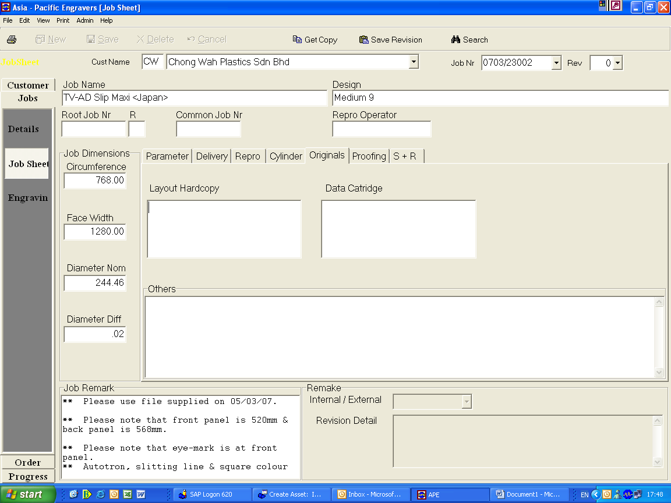

OVERVIEW
Input information on original digital file from customer.

RESPOSIBILITY
Sales Personnel

PROCESS PROCEDURE
On screen “JOBS – JOB SHEET – ORIGINALS”, type the information.

Note : Not in use at the moment.

2.2f) JOBS – JOB SHEET – PROOFIING – INPUT SCREEN

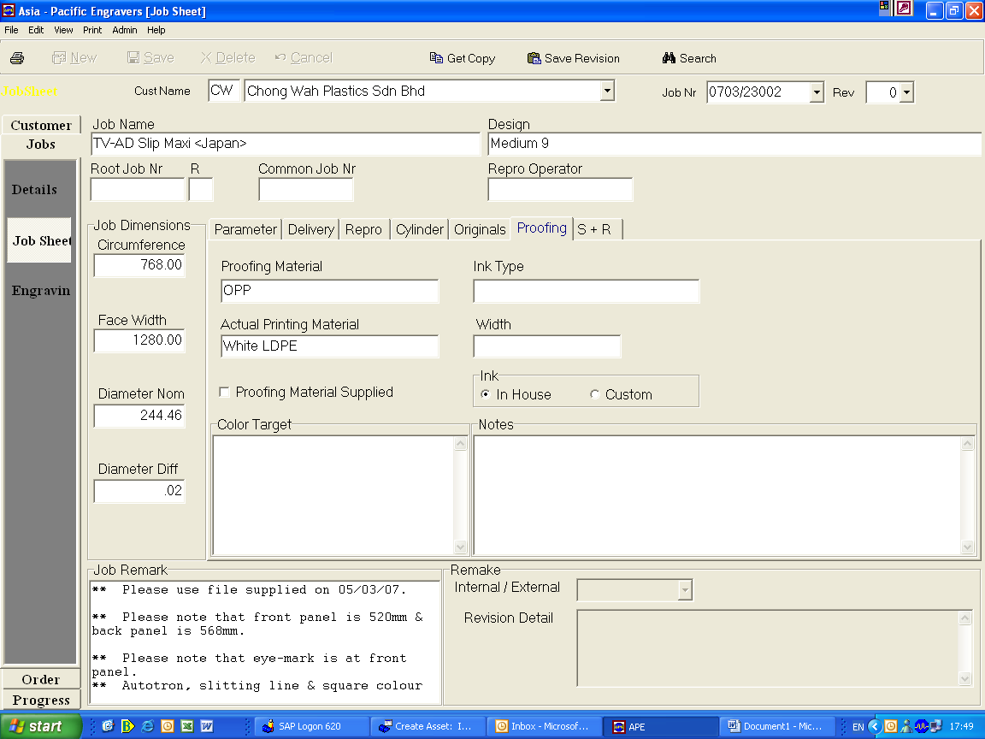

OVERVIEW
Input information on material to be use for proof print.

RESPOSIBILITY
Sales Personnel

PROCESS PROCEDURE
On screen “JOBS – JOB SHEET – PROOFING”, type the information. For ink type & width is not applicable.

2.2g) JOBS – JOB SHEET – S + R – INPUT SCREEN

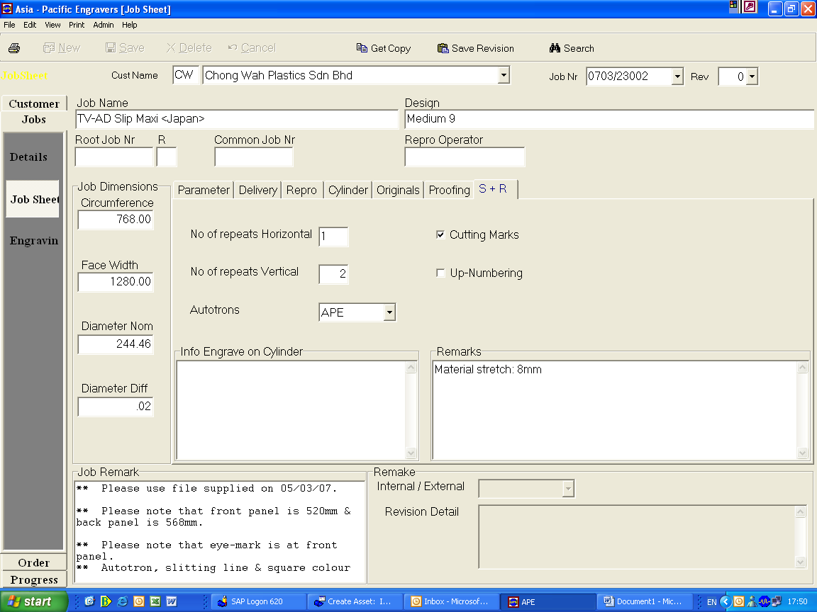

OVERVIEW
Input “Step & Repeat” information.

RESPOSIBILITY
Sales Personnel

PROCESS PROCEDURE
On screen “JOBS – JOB SHEET – S + R”, type the information.

Note : Autotrons means machine printing registration.

